**PROJECT PROPOSAL (3-SEVEN TETRIS by .DUEL)**

1. **Abstract**

3-SEVEN TETRIS is a game that combines the game concept of classic “Tetris” with “Dr. Mario” with a little basic arithmetic logic.

The game rules are simple,:

* In terms on getting the block to dissolve, players need to line up three blocks in either vertically, horizontally, or diagonally with to get a sum of the number “7” or three block with the number “7”.
* Once the block reached and touched the top of the space provided, the game will be forfeited.
* High score achieved by the total sum of the block dissolved and will be recorded individually to indicate the best player.

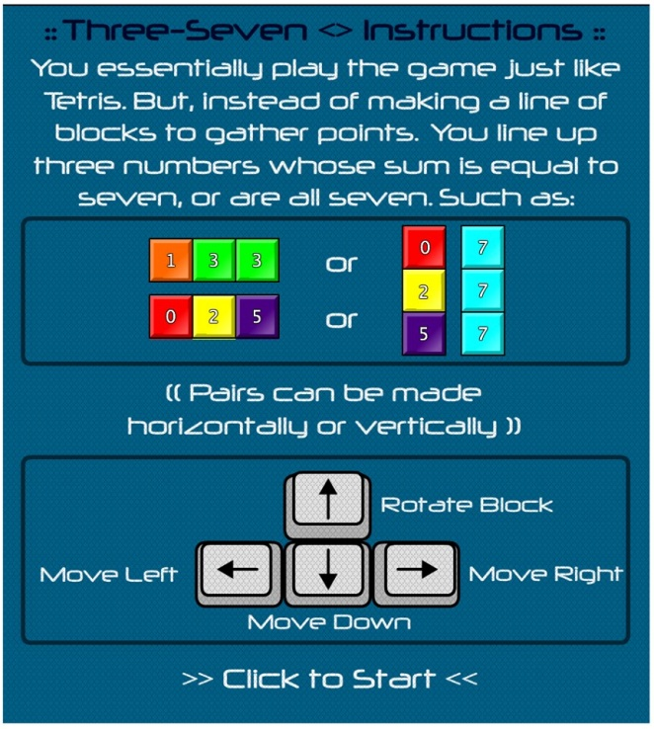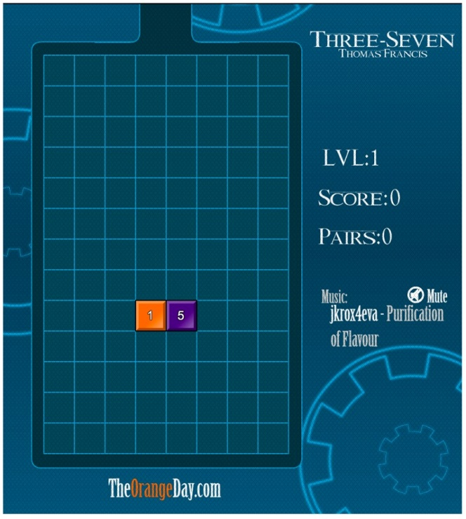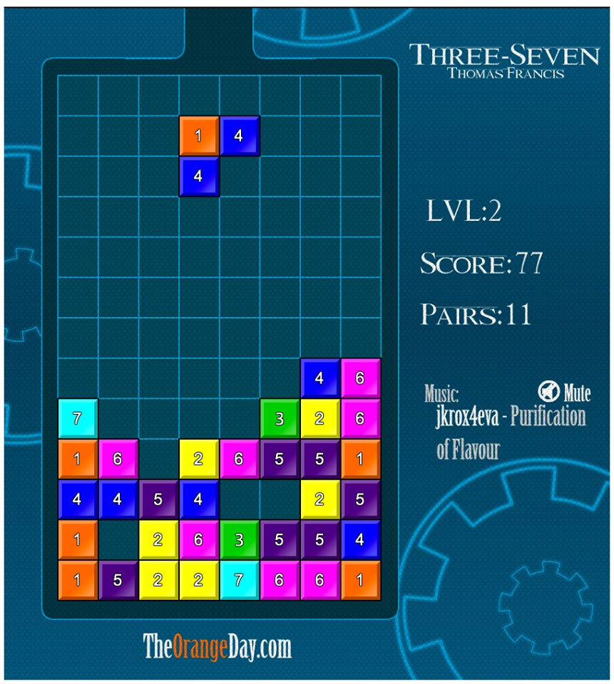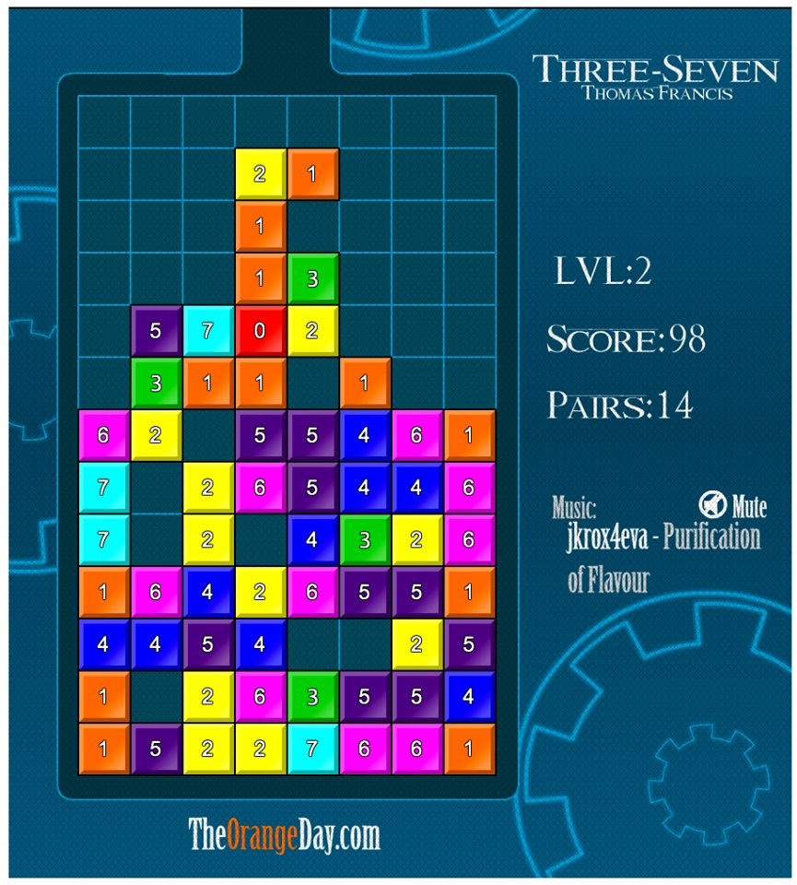

**2. Problem statement**

**Current problem:**

How to build a good user interface? User interface is build either in horizontal view or vertical view.

* Customers have to feel comfort with the interface so that the game is easy to play for them and strike for a high score.
* Horizontal and vertical view have their own good interface as the control button and the playing field (a rectangular vertical shaft, called the "well" or "matrix") are arranged differently in different view.

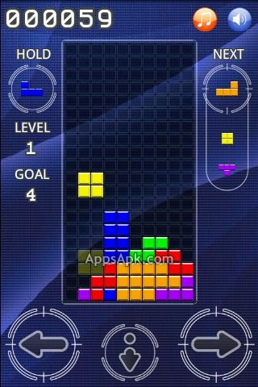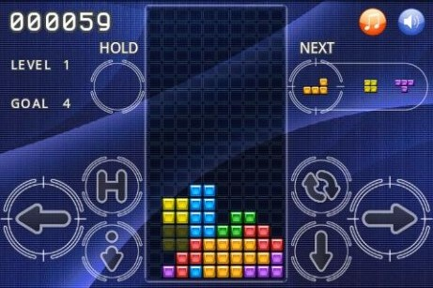

**Future problem:**

How to attract more people to play on this game?

* The more people involved in this game, the more confident game developers upgrade the game to make it more interesting.
* People would feel boring and mad when the game is full of bugs and have a bad interface.

**Problem statement:**

How do game developers build a good user interface and attract more people to involved and play on this game?

**3. Objectives**

* The objective of this game is to test players' collaboration between reflex and basic arithmetic skills.
* The game must have a good interface which contains control buttons, playing field, score board.
* Single mode: which is the basic mode for players to play the game in an offline mode and exceed personal scores.
* Multiplayer mode: which is an extra mode for players to play the game either with their friends or with other players over the world.
* High popularity and reputation: Popularity of the game will be increased once players start to rate the game based on stars.

**4. Scope**

|  |  |
| --- | --- |
| Scope | Description |
| Deliverables |  |
| Critical Success Factors | * To test players mathematical skills * To test players decision making * To let players have the chance to duel the game with their friends |
| Critical Success Measures |  |
| Constraints | * Only available for Android user. |
| Assumptions |  |

**5. Task Allocation**

|  |  |  |
| --- | --- | --- |
| Name | Role | Task/Description |
| LIM PEI YONG | 1. Project Manager | * Allocate project role to team members * Assign task to team members according to their role * Conduct brainstorming and meeting sessions with the team |
| 1. Planning Manager | * Plan meeting time among team members * Plan project development process * Plan development resources (e.g. API,SDK) |
| WILLIAM NGU WEE HONG | 1. Test Manager | * Test the game developed by team members |
| 1. Process Manager | * Execute development processes as planned * Design game rule * Provide development resources (e.g. API, SDK) * Execute process documentation |
| ABDUL RAHIM BIN MOHAMAD | 1. Customer Interface Manager | * Design game interface * Design player database |
| 1. Implementation Manager | * Implement the game rule/logic with the game interface |
| LIM CHONG FATT | 1. Quality Manager | * Determine the game quality |
| HOE YOU TIEN | 1. Support Manager | * Provide support on development processes |

**6. Team Goal**

Team goal of this project is to create “3-SEVEN TETRIS” game successfully. Duration of time to complete this project is 3 months.

**7. Team Contribution**

|  |  |  |  |  |  |
| --- | --- | --- | --- | --- | --- |
| Task \ Team members | A | B | C | D | E |
| Team Meeting |  |  |  |  |  |
| Research |  |  |  |  |  |
| Documentation |  |  |  |  |  |
| Testing |  |  |  |  |  |
| Total Hours |  |  |  |  |  |

|  |  |  |
| --- | --- | --- |
| Member’s Name | Student ID | Signature |
| A. LIM PEI YONG | 36732 |  |
| B. WILLIAM NGU WEE HONG | 39322 |  |
| C. ABDUL RAHIM BIN MOHAMAD | 35282 |  |
| D. LIM CHONG FATT | 36712 |  |
| E. HOE YOU TIEN | 36249 |  |

**8. Expected Result**

The expected result will be that the game created will let players to experience a different kind of game based on the mathematical skills either in single mode or in multiplayer mode.